Student Loan Hazards
Student loan forgiveness is a trendy topic these days. We will ignore questions about the politics with a capital 'P' that always come up in our hyperpartisan, democrat-vs-republican society as to whether or not this is meant by the current Administration as an attempt to Curry votes. Instead we will focus on the economic considerations (politics with the lowercase 'p') and the resulting behaviors, incentives, and moral hazards that result.
Speaking with some friends recently, the question came up as to whether COVID business loan forgiveness and student loan forgiveness are not each moral hazards and isn't hypocritical, as some are now doing, to condemn the former while condoning if not downright praising the latter. For those who need a refresher, a moral hazard is a term used by economists to describe how a societally undesirable behavior can result when an incentive is in place that shifts the risk or cost of the behavior from the agent performing the behavior to someone else.
It may seem odd that the term moral hazard can even attach to something as seemingly benign as loan forgiveness. After all, shouldn't we be sympathetic to the plight of people who are crushed under the weight of predatory loans? Or, maybe, the right way to express that question is to ask why we should we play favorites to careless fools who got their instant gratification by stupidly entering into a loan that they cannot afford. Neither of these foregoing questions really matter because, as is obvious, the framing of the question in both word choice and ethical viewpoint changes the way one answers the question. The better way to look at these questions is from the perspective of behavioral economics - how do the incentives built into the system drive the resulting behaviors and are these behaviors something we want.
Both types of loans, COVID business relief and student debt, fall outside the usual structure of a traditional loan in that neither required collateral to secure. But that is where the similarity ends.
The small businesses that received COVID-relief loans were profitable pre-pandemic. To be in business, each of them did everything society at asked; they went through all the necessary licensing compliance steps, they offered a good or service that people wanted, and they stayed on the right side of the law (at least overtly). Their need for a loan was due to society not keeping its part of the social contract when it decided that these businesses needed to be closed for the good of everyone in the face of the virus. None of these businesses engaged in risky behavior that led to the need for a loan but rather each was acting as good citizens when they agreed to forego their livelihood to comply with a situation that they neither caused nor directly contributed to. Any of the loans a business received during the shutdown resulted in no moral hazard since these loans were not incentivizing the behavior that led to the shutdown and, so, the corresponding loan forgiveness doesn't reward risky behavior society would explicitly want to avoid.
On the other hand, there was no compliance burden with which a prospective college student must comply; no gates that society made them go through before they were allowed to borrow. Nor were students required to receive a loan only for those degrees that were immediate useful to the broad public or in high demand. Instead, students pursuing any discipline were granted access to a virtually limitless budget for immediate transfer to an institution of higher learning. The only tangible restriction was that students taking out these loans were required to pay them back - no ability to get a clean slate even by declaring bankruptcy. This approach has led to a variety of moral hazards.
Student-held debt now outstrips consumer-held debt often in support of academic degrees that place students in a worse rather than better earning position. Larger and larger segments of students are defaulting on loan payments leaving lenders with continually shrinking returns on investment. Employers are citing students as being increasingly less-well prepared for real-world employment necessitating more training investment before an employee becomes productive.
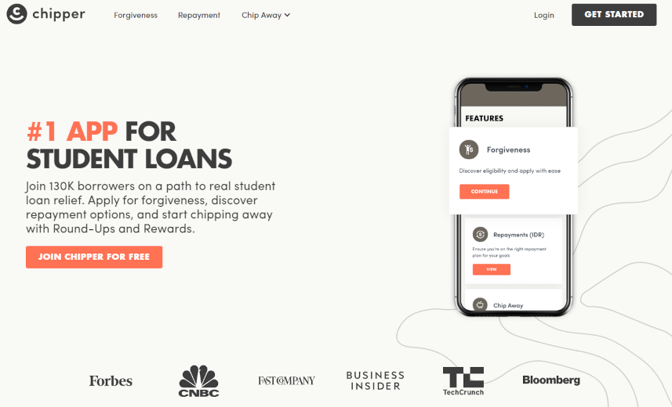
One school of thought blames students and their families for misusing a valuable resource. Their argument is that parents should know better than to allow their 18-year old child to pursue a degree in medieval French poetry without realistically assessing the likelihood of making a viable living pursuing his passion. These critics also point out the folly of parents buying into the idea that the only way their children can earn 'good money' is with an advanced degree. Another school of thought points out that colleges oversell the benefits of the campus experience by providing an ever-increasing set of amenities while downplaying the financial obligation each student assumes. As evidence they offer they fact that the rate of tuition growth has outstripped inflation by a factor of 2 or 3 over the past 30-40 years resulting in the 'big education bubble', which is very reminiscent of the big housing bubble of 2008 except for the fact that it hasn't yet popped.
Regardless of which of the above arguments one finds persuasive, the student loan program, by incentivizing risky behavior, is the poster child of moral hazards. Forgiving this student debt only compounds these problems by now eliminating the only possible good that could have resulted, namely that the crushing debt held by graduates and the misery that follows in its wake would finally force newer parents and students to reevaluate the value of a college degree. By forgiving student debt, the government has shifted the risk from students and colleges to workers who either have paid off their student debt or, worse still, never had student debt in the first place.
So, it is crystal clear that there is a fundamental difference between COVID-relief loan forgiveness and student-debt forgiveness in that the former simply constitutes a helping-hand for people who founds themselves victims of circumstances that they had nothing to do with while the latter is an encouragement for behavior that poses a clear and present moral hazard.

